**Name**: Deepesh Patil **MIS No**.: 112215055

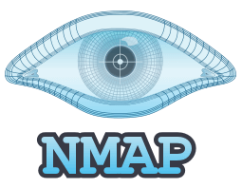

**APPLICATION**: Zenmap – A GUI for Nmap

**Introduction**

Nmap, developed by Gordon Lyon, is a powerful open-source network scanning tool that enables users to discover hosts, services, and vulnerabilities on computer networks. With its flexible command-line interface and extensive feature set, Nmap can conduct a wide range of scans, including port scans, OS detection, and version detection, allowing users to assess the security posture of their networks effectively. By providing detailed insights into network topology and potential security risks, Nmap empowers users to proactively identify and mitigate threats, strengthen their defences, and maintain the integrity and confidentiality of their systems and data.

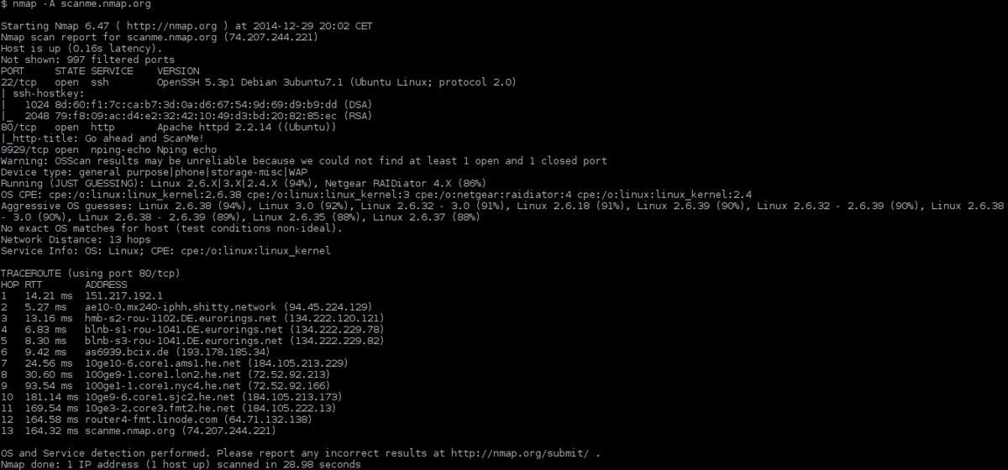

Zenmap is the official GUI for Nmap Security Scanner, enhancing accessibility to Nmap's robust capabilities across various platforms, including Linux, Windows, Mac OS X, and BSD. As a free and open-source application, Zenmap targets both novice and seasoned users by offering a user-friendly interface with advanced functionalities.

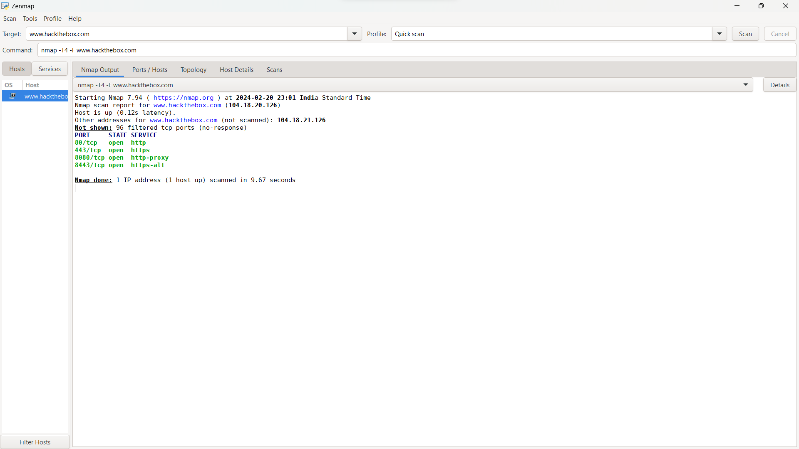

For beginners, Zenmap simplifies Nmap usage by providing intuitive controls and features, allowing easy execution of its functionalities. The command creator tool enables interactive creation of Nmap command lines, streamlining the scanning process. Additionally, Zenmap facilitates the storage and retrieval of scan results, enabling users to save, view, and compare recent scans.

On the other hand, Zenmap caters to experienced Nmap users by retaining the powerful capabilities of Nmap, such as network discovery and security auditing, within its graphical interface. Users can leverage Nmap's extensive features for in-depth network reconnaissance tasks while benefiting from Zenmap's streamlined and organized interface.

Zenmap simplifies network security assessments and penetration testing by providing a UI for Nmap. With scan profiles, result management, and integration with the Nmap Scripting Engine, Zenmap streamlines the scanning process and enables comprehensive network reconnaissance and vulnerability detection.

**History**



Nmap was, as an article in Phrack Magazine with source-code included. With help and contributions of the computer security community, development continued.

Zenmap was originally derived from Umit, an Nmap GUI created during the Google-sponsored Nmap Summer of Code in 2005 and 2006. The primary author of Umit was Adriano Monteiro Marques. When Umit was modified and integrated into Nmap in 2007, it was renamed Zenmap.

**Features/Functionalities**

Zenmap has various key features such as:

* GUI – Provides an intuitive GUI for beginners and for those users who don’t prefer CLI.
* Multi-Platform Support – Zenmap is compatible with various OS, including Linux, Windows, macOS, and BSD, ensuring flexibility and accessibility across different environments.

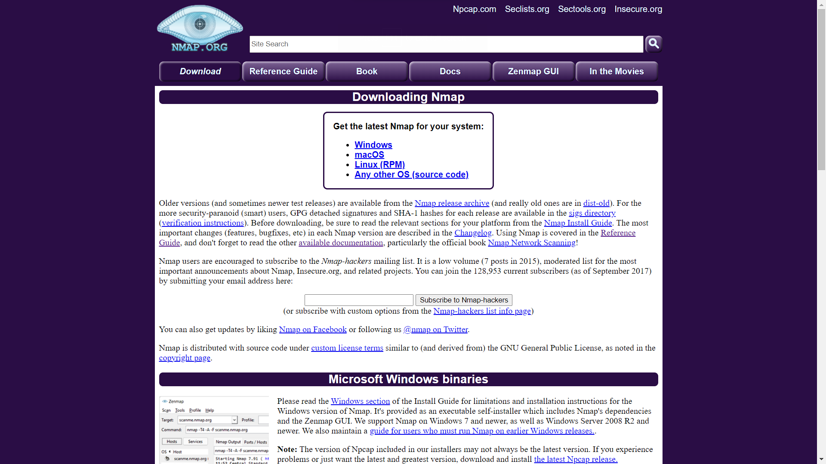.

* Scan Profiles – Users can create and save scan profiles, containing predefined configurations for common scanning tasks, streamlining the scanning process and ensuring consistency.
* Scan Management – Zenmap allows users to save, view, and compare scan results, enabling easy retrieval of past findings and facilitating analysis.
* Database Support – Zenmap stores scan results in a searchable database, allowing users to organize and manage scan data efficiently.
* Interactive Command Creator – Users can interactively create Nmap command lines within Zenmap, simplifying the scanning process for those less familiar with Nmap's syntax.
* NSE – Zenmap seamlessly integrates with NSE, enabling users to leverage custom scripts for advanced network exploration and vulnerability detection.

**GUI**

Zenmap's UI is designed to provide a straightforward and intuitive experience for users conducting network security assessments and penetration testing.

Components of the UI:-

* Navigation Bar - At the top, there is a navigation bar containing menu options for File, Edit, Scan, Profiles, Hosts, and Help. These options provide access to various features and settings within Zenmap.

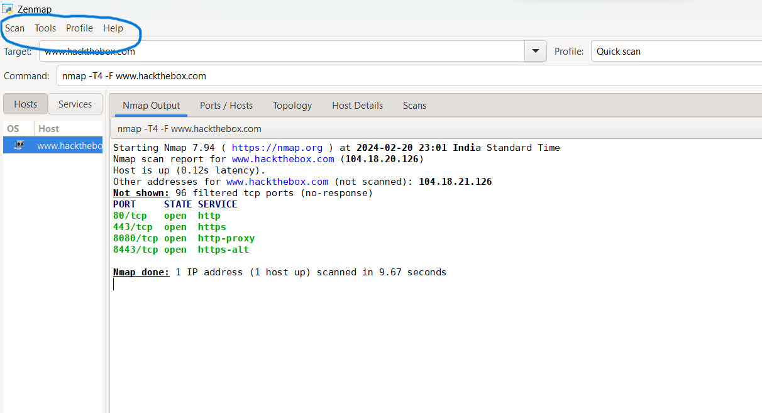

* Scan Tab – The Scan tab is where users configure and initiate network scans. It provides options for selecting scan types, specifying target hosts, defining scan parameters, and setting scan intensity levels.
* Tools Tab – This tab allows us to search and compare scan results and also allows us to filter hosts.
* Profile Management – Users can create, save, and load scan profiles from the Profiles menu. Scan profiles store predefined configurations for different scanning scenarios, enabling users to quickly initiate scans with specific settings.
* Help Tab – This tab helps us to get the Zenmap Documents, see information such as version of the application and also allows us to report bugs.

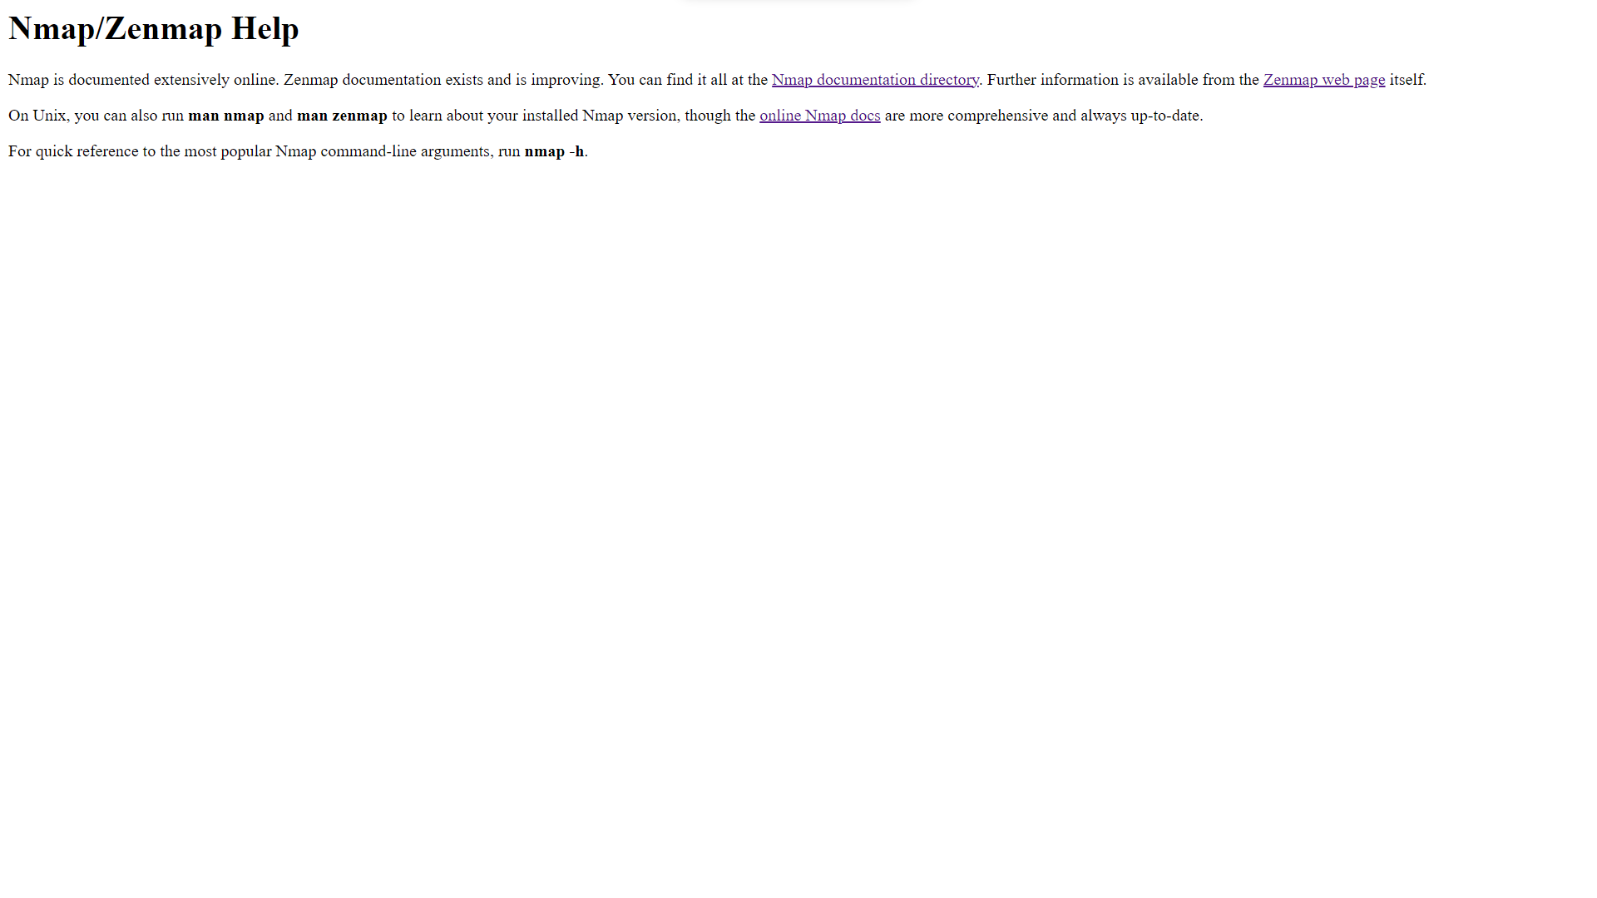

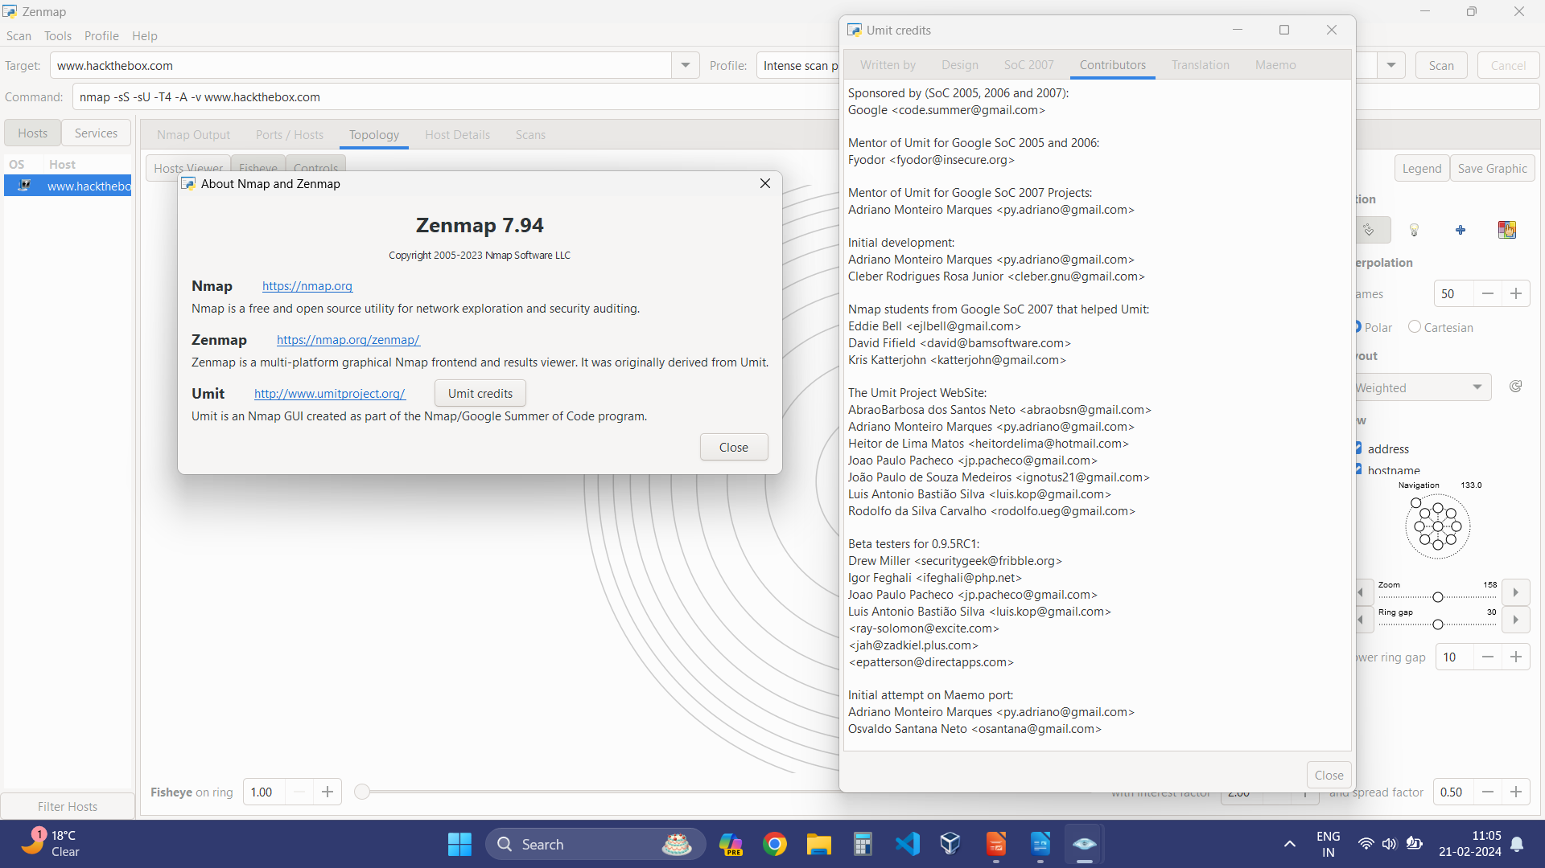

* Target Bar – This displays the host/target during a scan.

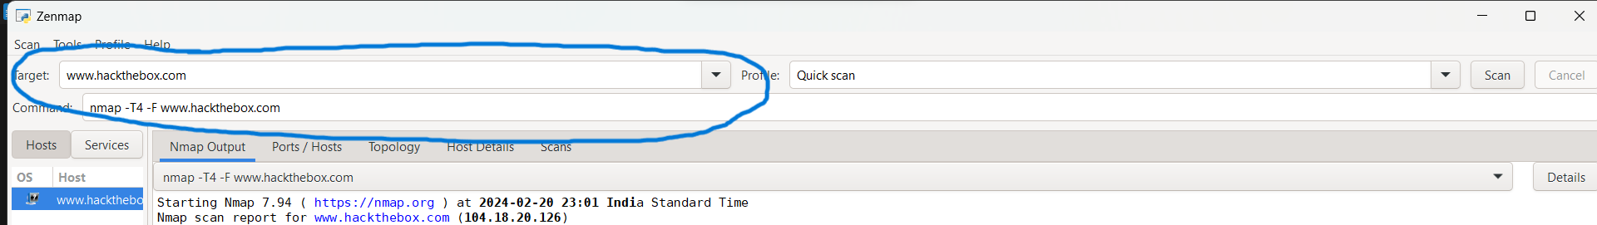

* Profile Bar – There is another profile bar which allows us to select which type of scan is preferred, for eg. Intense Scan(Default), Ping Scan, Quick Scan, etc.

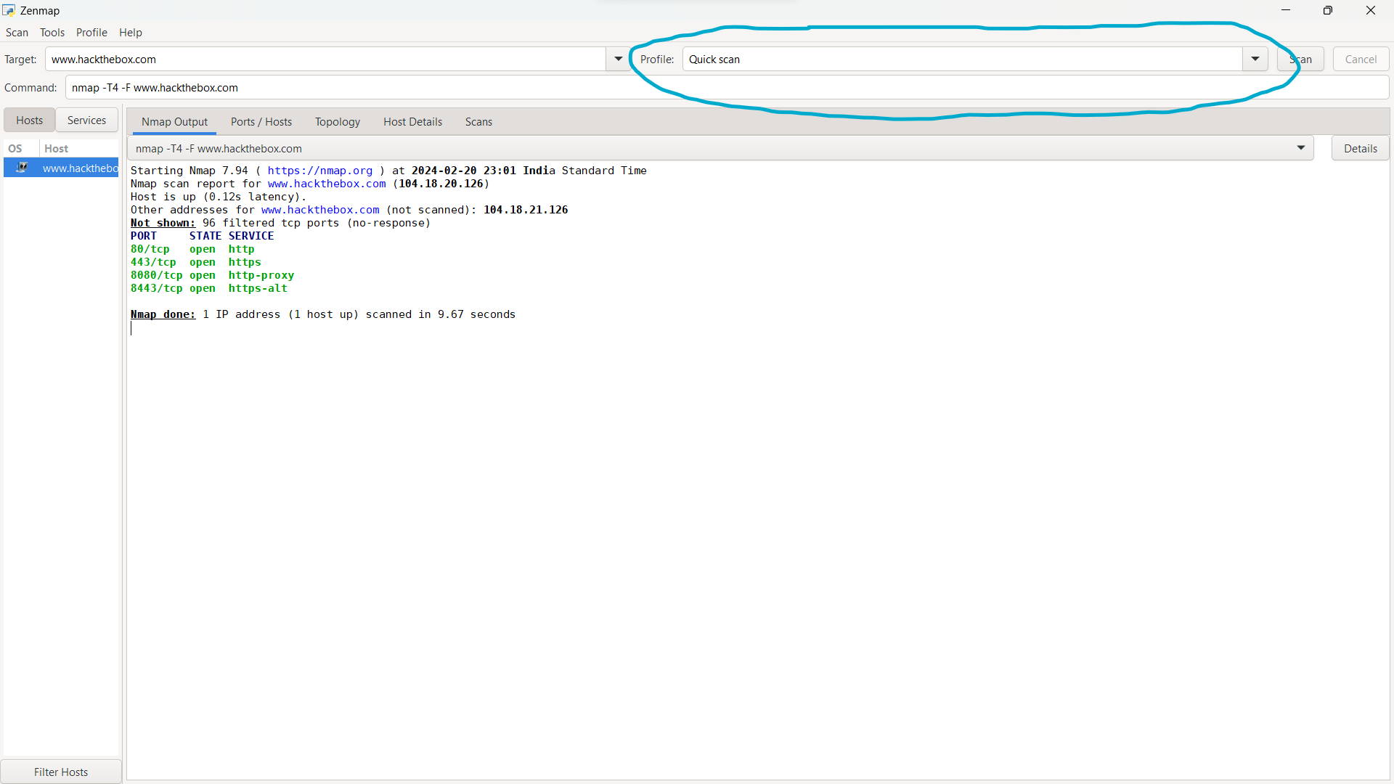

* Scan/Cancel Button – Button to initiate the Scan and to stop the scan before completing.
* Command Bar – This helps in generating a command for the operation that is being performed.

For eg: nmap -T4 -A -v <IP/Host Addr.>

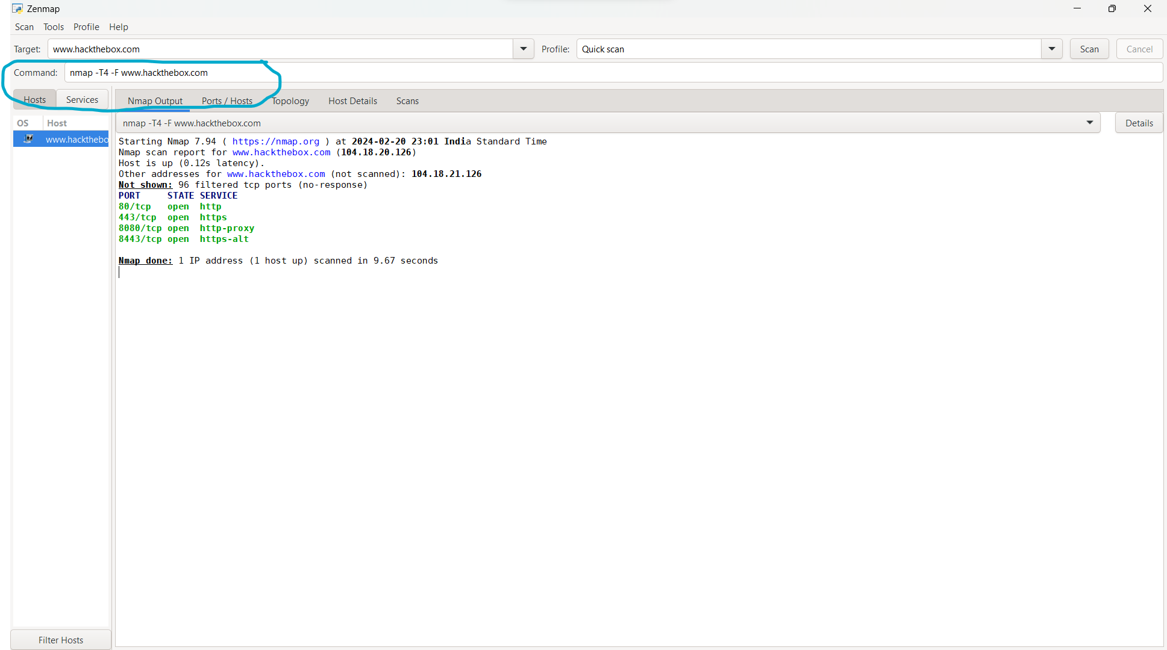

* Console Output – Zenmap provides a console window that shows real-time output and status messages during scans. Users can monitor the progress of scans, view verbose output, and troubleshoot any errors or issues encountered.

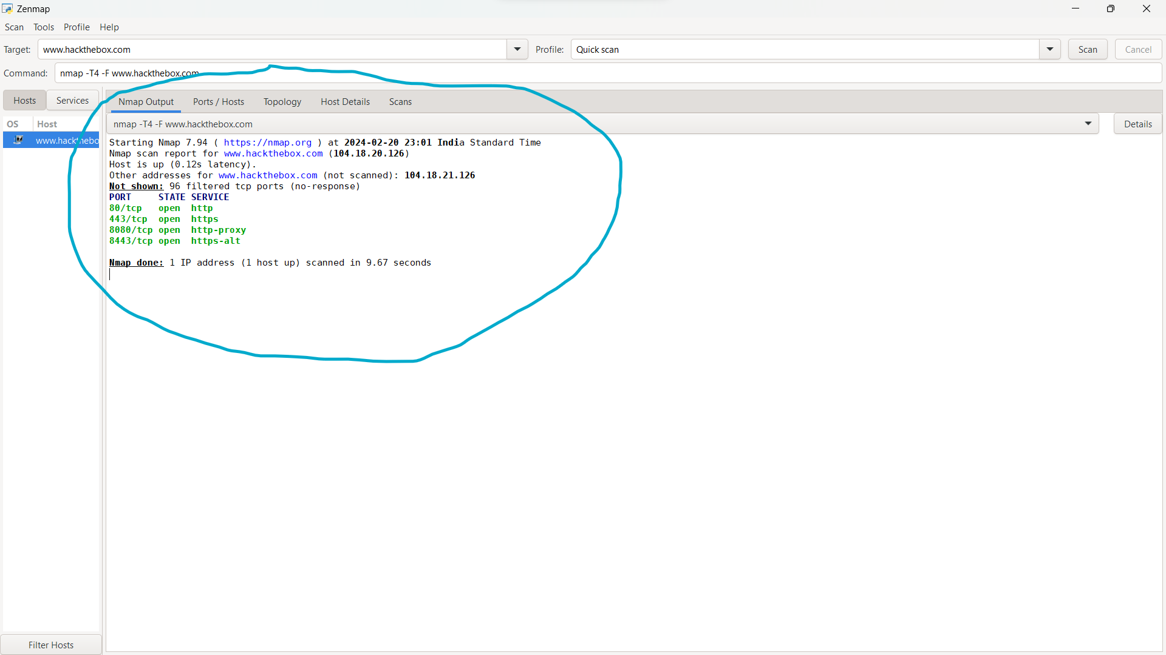

* Ports/Hosts – This allows us to see all the open ports.

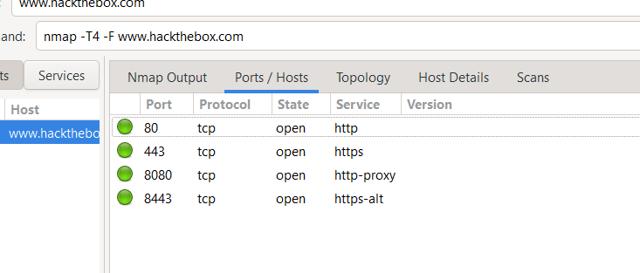

* Host Details – This gives us all the details of the host.

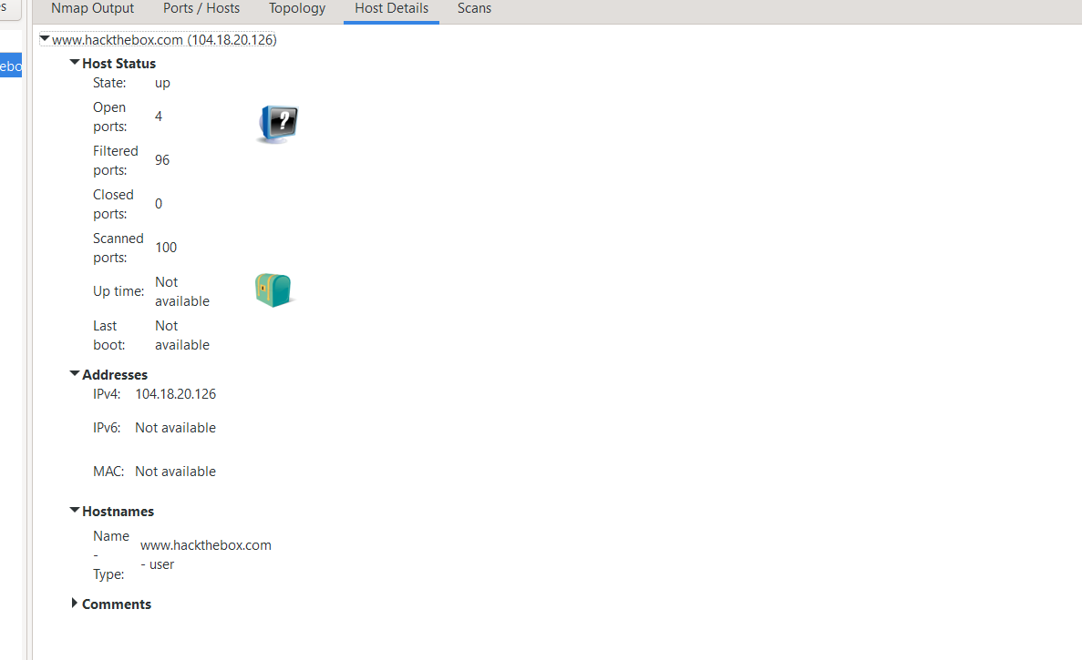

* Scans – This keeps a track of our previous scans and also weather they are saved or not.

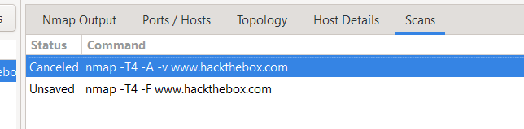

* Interactive Map – Zenmap features an interactive network map that visualizes the topology of scanned networks. The map displays hosts, services, and connections graphically, providing users with a visual representation of network assets and relationships.

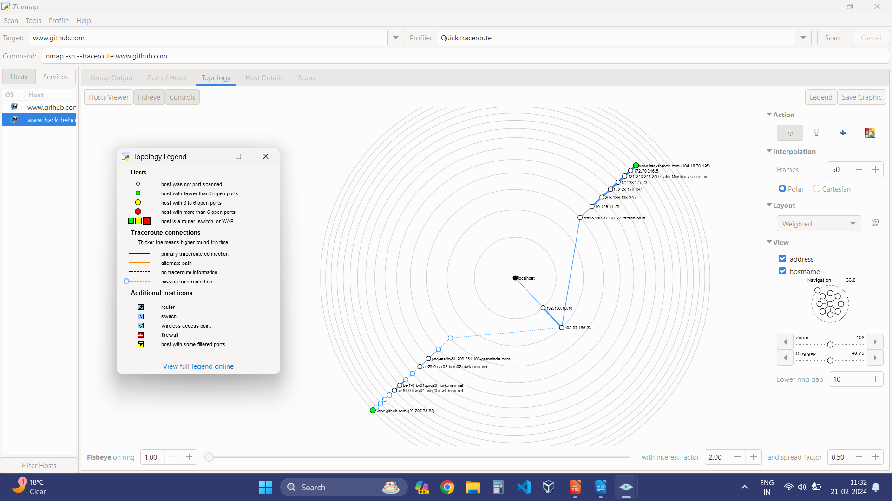

* Filter Host – This option allows us to filter the information based on hosts, usually located at the left-bottom of the Application

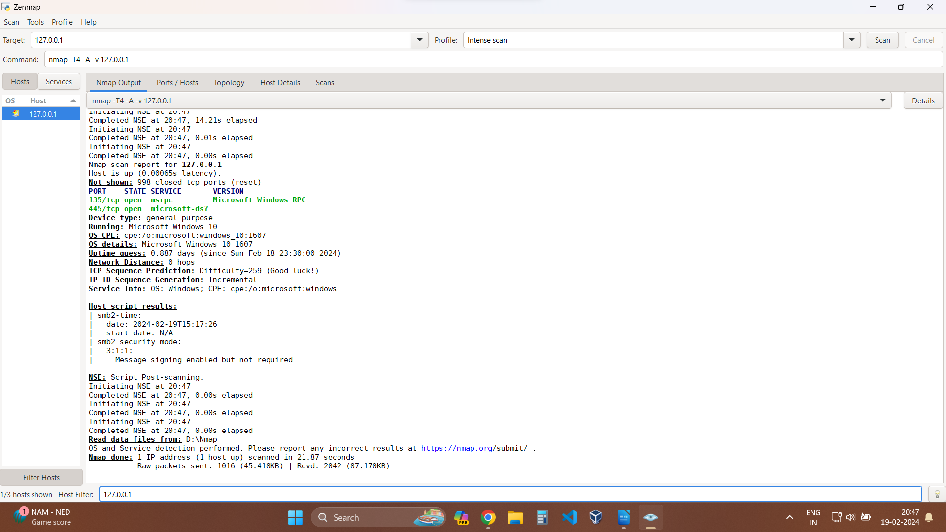

**Scan Profiles**

Zenmap's scan profiles are preconfigured settings that help in scanning by providing predefined configurations for common scanning scenarios.

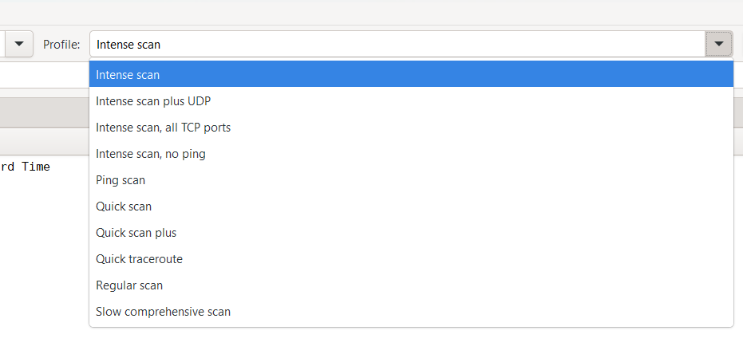

* Intense Scan – This profile performs a thorough scan of the target network, focusing on the most commonly used port numbers and services. It balances thoroughness with speed, making it suitable for general network reconnaissance.
* Intense Scan, Plus UDP – In addition to TCP ports, this profile also scans for UDP ports, which are often used for services such as DNS and DHCP. It provides a comprehensive view of both TCP and UDP services running on the network.
* Intense Scan, All TCP Ports – This profile scans all TCP ports on the target hosts, providing a more exhaustive examination of potential services and vulnerabilities. It is useful for thorough security assessments but may take longer to complete.
* Intense Scan, No Ping – This profile skips the host discovery phase and directly scans the specified targets, regardless of whether they respond to ping requests. It is useful for scanning hosts that may have ICMP (ping) responses disabled.
* Ping Scan – This profile performs a quick ping scan of the target network to identify live hosts. It is useful for quickly discovering active hosts before conducting more in-depth scanning operations.
* Quick Scan – This profile performs a fast scan of the target network, focusing on the most common ports and services. It prioritizes speed over thoroughness, making it suitable for initial reconnaissance or time-sensitive assessments.
* Quick Scan Plus – This profile combines a quick port scan with service version detection (-sV), OS detection (-O), and light version detection (--version-light). It provides additional information about detected services and operating systems.
* Regular Scan – This profile allows users to customize scan parameters according to their specific requirements. Users can manually configure scan options, such as scan type, target hosts, port range, and timing options, to tailor the scan to their needs.

**Scan Results**

Zenmap presents scan results to users in a clear and organized manner, providing detailed information about the scanned network, hosts, and services.

* Host Summary:

- Zenmap displays a summary of the hosts discovered on the network. This summary includes the IP addresses, hostnames (if available), MAC addresses, and status (e.g., up or down) of each host.

- Hosts are grouped and colour-coded based on their status, making it easy to identify active hosts and potential issues.

* Port and Service Information:

- For each scanned host, Zenmap provides detailed information about the open ports and detected services.

- The port number, protocol (TCP/UDP), and service name (if identified) are listed for each open port.

- Additional information, such as service version, product name, and protocol version, may be included depending on the scan settings and service detection capabilities.

* Operating System Detection:

- Zenmap attempts to detect the operating system running on scanned hosts and provides this information in the scan results.

- Detected operating systems are listed along with a confidence level indicating the accuracy of the detection.

* Vulnerability Detection:

- Zenmap may identify potential vulnerabilities or security issues based on the scan results.

- Vulnerabilities are reported along with relevant details, such as CVE (Common Vulnerabilities and Exposures) identifiers and severity ratings.

* Interactive Network Map (Topology):

- Zenmap includes an interactive network map that visually represents the topology of the scanned network.

- Hosts, ports, and connections are graphically depicted on the map, allowing users to visualize the relationships between network assets.

* Searchable Results Table:

- Scan results are presented in a tabular format, allowing users to view and filter the data based on various criteria.

- Users can search for specific hosts, ports, services, or other attributes within the results table, making it easy to locate relevant information.

* Console Output:

- Zenmap provides a console window that displays real-time output and status messages during the scan.

- Users can monitor the progress of scans, view verbose output, and troubleshoot any errors or issues encountered.

**Advance Features of Zenmap**

Zenmap, as the GUI for the Nmap Security Scanner, offers several advanced features that enhance its functionality and usefulness in network reconnaissance and security auditing.

* Profile Management – Zenmap allows users to create, save, and manage scan profiles with custom configurations. Users can define specific scan parameters, target specifications, timing options, and output formats for different scanning scenarios.
* Scripting Engine Integration – Zenmap seamlessly integrates with Nmap's scripting engine (NSE), allowing users to execute custom scripts during scans for advanced functionality such as vulnerability detection, service enumeration, and network fingerprinting.
* Scan Aggregation and Comparison – Zenmap enables users to aggregate and compare scan results from multiple scans. Users can save scan results to a database and compare them to identify changes in the network over time, track vulnerabilities, and assess the effectiveness of security measures.
* Customizable Output Formats – Zenmap offers customizable output formats for scan results, including interactive graphical maps, HTML reports, XML output for further analysis, and plain text reports. Users can tailor the output format to suit their preferences and reporting requirements.
* Scan Configuration Wizard – Zenmap includes a scan configuration wizard that guides users through the process of setting up and running scans. The wizard simplifies the scan configuration process for beginners and ensures that users select appropriate options for their scanning needs.
* Real-time Scan Monitoring – Zenmap provides real-time monitoring of scan progress and results through its console output window. Users can monitor the status of ongoing scans, view verbose output, and troubleshoot any errors or issues encountered during the scanning process.
* Graphical Network Visualization – Zenmap includes an interactive network map that visually represents the topology of the scanned network. Users can explore the network map to identify hosts, ports, and connections, making it easier to understand the network layout and relationships between assets.
* Integration with Other Tools – Zenmap integrates with other security tools and frameworks, allowing users to leverage additional capabilities for network analysis and security assessment. Integration options may include exporting scan results to third-party tools or importing data from external sources.

**Scripting Engine**

The Nmap Scripting Engine (NSE), a powerful feature of the Nmap Security Scanner of the Zenmap GUI, allows users to extend the functionality of Nmap by writing and executing custom scripts during the scanning process. These scripts can perform various tasks, such as service detection, vulnerability scanning, host discovery, and network reconnaissance. This enhances the scanning capabilities and obtain more comprehensive information about the target network. The scripting feature enables users to automate repetitive tasks, conduct advanced security assessments, and uncover potential vulnerabilities or misconfiguration.

Key aspects of scripting in Zenmap include:

* Script Selection - Zenmap provides a friendly UI for selecting and executing NSE scripts. Users can choose from a wide range of built-in scripts covering different aspects of network scanning and security testing.
* Script Output - When executing NSE scripts, Zenmap displays the output directly within the graphical interface, allowing users to view the results in real-time. The output may include information about discovered services, detected vulnerabilities, or other relevant data.
* Script Management Zenmap offers options for managing NSE scripts, including enabling/disabling specific scripts, updating script databases, and customizing script parameters. Users can tailor the script execution to suit their scanning requirements and objectives.
* Custom Script Development - Advanced users can develop their own custom NSE scripts to address specific needs or perform specialized tasks during network scanning. Zenmap provides support for loading and executing custom scripts, empowering users to extend the capabilities of the tool according to their expertise and requirements.

**Application of Zenmap**

Zenmap, as the graphical user interface for the Nmap Security Scanner, finds various applications across different domains due to its robust features and capabilities. Some common use cases and applications of Zenmap include:

* Network Discovery - Zenmap is widely used for network discovery tasks, allowing administrators to identify active hosts, open ports, and services running on the network. It enables users to create comprehensive inventories of network assets and infrastructure components.
* Vulnerability Assessment - Security professionals utilize Zenmap for vulnerability assessment and penetration testing activities. By scanning target networks for known vulnerabilities, misconfiguration, and security weaknesses, Zenmap helps organizations identify potential risks and prioritize remediation efforts.
* Security Auditing - Zenmap facilitates security auditing by conducting thorough scans of network environments to assess compliance with security policies, industry regulations, and best practices. It enables organizations to identify security gaps, unauthorized access points, and potential threats to their systems.
* Intrusion Detection - Zenmap can be employed for intrusion detection purposes to monitor network traffic, detect suspicious activities, and identify potential security breaches or unauthorized access attempts. By continuously scanning the network, Zenmap helps organizations stay vigilant against security threats.
* Network Mapping and Visualization - Zenmap provides graphical network maps and visualizations that depict the topology of scanned networks, including host relationships, interconnections, and traffic flows. This visual representation assists administrators in understanding the network layout and identifying potential attack vectors.
* Forensic Analysis - Security incident response teams leverage Zenmap for forensic analysis and investigation of security incidents. By analysing scan results and historical data, Zenmap helps investigators reconstruct events, identify compromised systems, and determine the scope and impact of security breaches.
* Compliance Monitoring - Organizations use Zenmap to monitor and ensure compliance with regulatory requirements, industry standards, and internal security policies. By conducting regular network scans and audits, Zenmap helps organizations demonstrate compliance and maintain a strong security posture.
* Risk Management - Zenmap supports risk management initiatives by providing insights into the security posture of networks and IT infrastructures. It assists organizations in identifying and mitigating risks, prioritizing security investments, and making informed decisions to protect critical assets.
* Penetration Testing - Ethical hackers and penetration testers utilize Zenmap as part of their toolkit for conducting penetration tests and security assessments. By simulating real-world attack scenarios, Zenmap helps testers identify vulnerabilities, exploit weaknesses, and provide recommendations for improving security defences.

Thus, Zenmap serves as a versatile and powerful tool for network reconnaissance, security assessment, and risk management, making it invaluable for organizations seeking to enhance their cybersecurity posture and protect against evolving threats.

**Drawbacks/Limitations**

While Zenmap offers numerous benefits for network scanning and security testing, it also has certain limitations and challenges that users may encounter:

* Resource Intensive – Zenmap can be resource-intensive, especially when scanning large networks or conducting comprehensive scans with numerous options enabled. This may lead to high CPU and memory usage, potentially impacting system performance.
* Complexity for Novice Users – Despite being a graphical interface, Zenmap still requires some level of technical expertise to effectively configure and interpret scan results. Novice users may find it challenging to understand and utilize all available features without prior knowledge of networking concepts and security principles.
* Limited Platform Support – While Zenmap is compatible with multiple operating systems (Linux, Windows, macOS, etc.), some advanced features or specific functionalities may not be fully supported on certain platforms. Users may encounter platform-specific issues or limitations during scanning and analysis.
* Dependency on Nmap – Zenmap relies on the Nmap Security Scanner for core scanning functionality. Changes or updates to Nmap may affect Zenmap's performance or compatibility, requiring users to keep both applications up-to-date and synchronized.
* Scan Timing and Network Congestion – Conducting network scans with Zenmap can sometimes lead to network congestion or disruption, particularly during peak hours or on congested networks. Users must carefully schedule scans to minimize impact on network performance and avoid potential conflicts with critical operations.
* False Positives/Negatives – Like any scanning tool, Zenmap may occasionally produce false positives (incorrectly identifying vulnerabilities or misconfiguration) or false negatives (missing genuine security issues). Users should carefully validate scan results and cross-reference findings with other security tools or manual assessments.
* Firewall and IDS Interference – Zenmap scans may be blocked or detected by firewalls, intrusion detection systems (IDS), or other security mechanisms, especially when conducting aggressive or intrusive scans. Users may need to adjust scan parameters or obtain proper authorization to bypass security controls.
* Legal and Ethical Considerations – Unauthorized or improper use of Zenmap for scanning networks without proper authorization may violate legal regulations, ethical guidelines, or organizational policies. Users must adhere to applicable laws and ethical standards when performing security assessments and penetration testing.
* Documentation and Support – While Zenmap provides comprehensive documentation and user guides, users may still encounter challenges or questions that require additional support. Access to timely and accurate technical support resources can be essential for resolving issues and optimizing tool usage.
* Compatibility with Third-party Tools – Integration with third-party tools, frameworks, or environments may pose compatibility challenges or require additional configuration. Users should carefully assess interoperability requirements and verify compatibility before deploying Zenmap in complex environments.

**Conclusion**

In conclusion, the Zenmap manual serves as a comprehensive guide for users seeking to leverage the powerful capabilities of the Nmap Security Scanner through its intuitive graphical interface. Throughout the manual, users are provided with detailed instructions, explanations, and examples to facilitate the effective use of Zenmap in various network reconnaissance, security assessment, and penetration testing scenarios.

By exploring the manual's contents, users gain insights into Zenmap's key features, including its ability to conduct network scans, identify active hosts and open ports, and analyse scan results for potential vulnerabilities and security risks. The manual also covers advanced topics such as custom scan profiles, scripting, and integration with third-party tools, enabling users to tailor Zenmap to their specific requirements and optimize its performance in diverse environments.

Overall, the Zenmap manual serves as a valuable resource for both novice users, empowering them to leverage Zenmap effectively in their network security operations, enhance their understanding of network topology and vulnerabilities, and strengthen their cybersecurity defences against evolving threats. Through continued exploration, experimentation, and learning, users can harness the full potential of Zenmap to protect their networks, assets, and sensitive information from malicious actors and security breaches.

**References**

https://nmap.org/

https://nmap.org/zenmap/

https://nmap.org/download.html

https://nmap.org/book/man.html

<https://gbhackers.com/information-gatheri-using-nmap/>

https://www.freecodecamp.org/news/what-is-nmap-and-how-to-use-it-a-tutorial-for-the-greatest-scanning-tool-of-all-time/

<https://www.javatpoint.com/what-is-nmap>